FINAL EXAMINATION
TIME ALLOWED: 90’
Subject: Linear Algebra. No books allowed.

- Among all complex numbers that satisfied 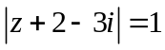, find the number z such that
module of z is minimum.
- Find 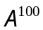, where 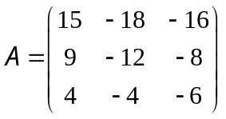 (given 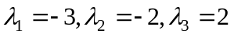 are three
eigenvalues of A).

- Let 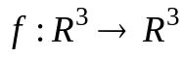 be a linear transformation.
Assume that . Find a dimension and one basic for Kerf.

- Let be a linear transformation, whose the matrix with respect to the basic
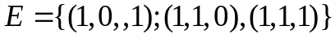 is 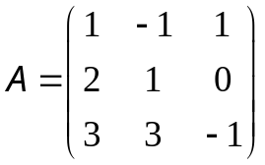.
a/ Compute 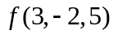.
b/ Find a dimension and one basic for 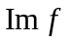.
- Given an inner product in 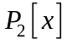 as follow: 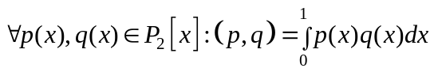.
Let 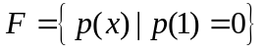 be a subspace of .
Find a dimension and one basic for the orthogonal complement of .
- Let A be the square real matrix of order 3 and A has two eigenvalues: 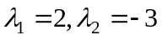.
The basic for the eigenspace 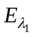 is 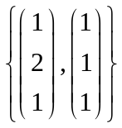, basic for the eigenspace is 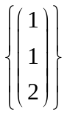.
Determine all value(s) m such that the vector 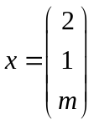 is an eigenvector for A.
- Make a change of variables that transforms the quadratic form
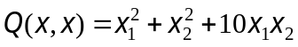 into the canonic form.

-----------------------  -----------------------

